**Code to identify the Correlations:**

import numpy as np

# Data

factor = []

happiness_rank = []

# the empty arrays should include values for the specific factor coming in the appropriate order depending

# on the order of the years (2015-2019), i.e. the first 5 values are values of one country across the years, the

# second five values are values of the another country and so on

correlation = np.corrcoef(social_support, happiness_rank)[0, 1]

print("The correlation between Factor and Happiness Rank is:", correlation)

**Prompt for ChatGPT to insert values into the arrays so that then execute the prepared code for finding a correlation in the online compiler (substitute the table with the actual table from Tableau):**

What is the correlation here between Social Support and Happiness Rank across the years 2015-2019 in the following table that list in the period:

Country Measure Names Measure Values

Afghanistan Family 0.30285

Afghanistan Family (2016.csv) 0.11037

Afghanistan Family (2017.csv) 0.581543326

Afghanistan Social support 0.537

Afghanistan Social support (2019.csv) 0.517

Afghanistan Happiness Rank 153

Afghanistan Happiness Rank (2016.csv) 154

Afghanistan Happiness.Rank 141

Afghanistan Overall rank 145

Afghanistan Overall rank (2019.csv) 154

Armenia Family 0.77711

Armenia Family (2016.csv) 0.62477

Armenia Family (2017.csv) 1.007483721

Armenia Social support 0.99

Armenia Social support (2019.csv) 1.055

Armenia Happiness Rank 127

Armenia Happiness Rank (2016.csv) 121

Armenia Happiness.Rank 121

Armenia Overall rank 129

Armenia Overall rank (2019.csv) 116

Burundi Family 0.41587

Burundi Family (2016.csv) 0.23442

Burundi Family (2017.csv) 0.629793584

Burundi Social support 0.627

Burundi Social support (2019.csv) 0.447

Burundi Happiness Rank 157

Burundi Happiness Rank (2016.csv) 157

Burundi Happiness.Rank 154

Burundi Overall rank 156

Burundi Overall rank (2019.csv) 145

Madagascar Family 0.66801

Madagascar Family (2016.csv) 0.46115

Madagascar Family (2017.csv) 0.913020372

Madagascar Social support 0.908

Madagascar Social support (2019.csv) 0.916

Madagascar Happiness Rank 147

Madagascar Happiness Rank (2016.csv) 148

Madagascar Happiness.Rank 144

Madagascar Overall rank 143

Madagascar Overall rank (2019.csv) 143

Mauritania Family 0.86908

Mauritania Family (2016.csv) 0.84142

Mauritania Family (2017.csv) 1.272030830

Mauritania Social support 1.245

Mauritania Social support (2019.csv) 1.167

Mauritania Happiness Rank 124

Mauritania Happiness Rank (2016.csv) 130

Mauritania Happiness.Rank 123

Mauritania Overall rank 126

Mauritania Overall rank (2019.csv) 122

Palestinian Territories Family 0.92558

Palestinian Territories Family (2016.csv) 0.71629

Palestinian Territories Family (2017.csv) 1.155647159

Palestinian Territories Social support 1.217

Palestinian Territories Social support (2019.csv) 1.247

Palestinian Territories Happiness Rank 108

Palestinian Territories Happiness Rank (2016.csv) 108

Palestinian Territories Happiness.Rank 103

Palestinian Territories Overall rank 104

Palestinian Territories Overall rank (2019.csv) 110

United Arab Emirates Family 1.12575

United Arab Emirates Family (2016.csv) 0.87114

United Arab Emirates Family (2017.csv) 1.266410232

United Arab Emirates Social support 0.776

United Arab Emirates Social support (2019.csv) 1.31

United Arab Emirates Happiness Rank 20

United Arab Emirates Happiness Rank (2016.csv) 28

United Arab Emirates Happiness.Rank 21

United Arab Emirates Overall rank 20

United Arab Emirates Overall rank (2019.csv) 21

Uruguay Family 1.2089

Uruguay Family (2016.csv) 1.03143

Uruguay Family (2017.csv) 1.412227869

Uruguay Social support 1.459

Uruguay Social support (2019.csv) 1.465

Uruguay Happiness Rank 32

Uruguay Happiness Rank (2016.csv) 29

Uruguay Happiness.Rank 28

Uruguay Overall rank 31

Uruguay Overall rank (2019.csv) 33

Calculate using the following code, but replace freedom with social support and corresponding values from the table:

import numpy as np

# Data

freedom = [0.23414, 0.1643, 0.106179520, 0.085, 0, 0.19847, 0.14037, 0.198303267, 0.26, 0.283, 0.1185, 0.0432, 0.059900753, 0.065, 0.22, 0.19184, 0.13684, 0.189196765, 0.221, 0.148, 0.24232, 0.1268, 0.096098043, 0.129, 0.066, 0.24499, 0.17744, 0.254711062, 0.266, 0.225, 0.64157, 0.56215, 0.608345270, 0.284, 0.598, 0.60362, 0.54388, 0.579392254, 0.625, 0.523]

happiness_rank = [153, 154, 141, 145, 154, 127, 121, 121, 129, 116, 157, 157, 154, 156, 145, 147, 148, 144, 143, 143, 124, 130, 123, 126, 122, 108, 108, 103, 104, 110, 20, 28, 21, 20, 21, 32, 29, 28, 31, 33]

**Example of using this prompt:**

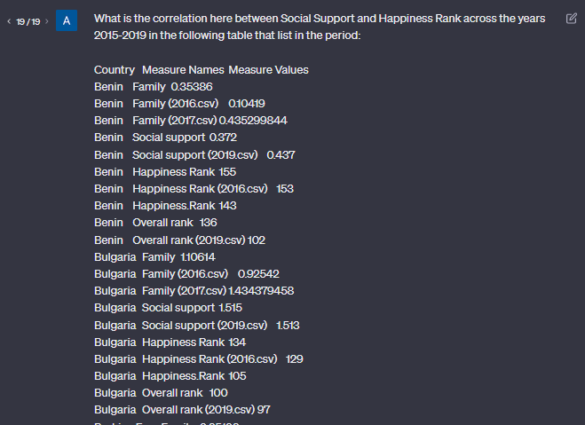

**…**

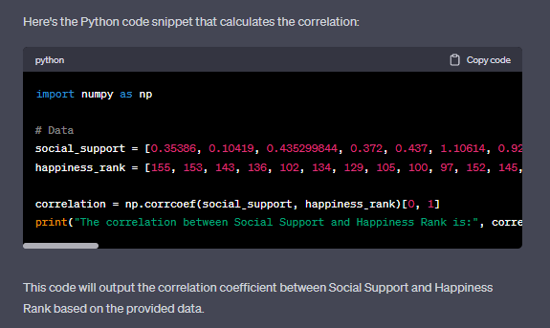

So, we copied the ready code with the inserted values into the online compiler and identified this way the correlation.

**Sample Prompt for ChatGPT to get a sentiment of the findings (at the end of analysis of the specific type of countries):**

There are 8 factors that affect the Happiness Rank of a country.

Factors: GDP per capita, Freedom for making life choices, Health (Life Expectancy), Generosity, Corruption, Social Support

The measuring unit of all these factors is the extent to which they contribute to making life evaluations higher (the Happiness Score)

So after calculating correlations between these factors and the happiness rank of a country the following is determined:

GDP is negatively moderately correlated

Freedom is positively weakly correlated

Health is negatively moderately correlated

Generosity is positively weakly correlated

Corruption is negatively weakly correlated

Social Support is negatively weakly correlated

When the correlation is negative that means that this factor affects positively on the happiness level

So, write an analysis of this situation